|  |  |
| --- | --- |
| Critical Information Summary | |
| Student Name | SOCHAN MAO |
| SID | 217176271 |
| Mark Aimed For (%) | 95 |

### Criteria: Weekly zip uploads [HD]

* I have uploaded every week since week 3, so it is 7 weeks including week 10

### Criteria: Weekly Progress [Distinction]

* I have listed what I have done recently for each week and sometime planning for next coming week in changelog.txt

### Criteria: Code quality [Distinction]

* Indentation for every part of codes, functions or sub sections
* Comments to some important part or function description
* Full explanation to each function with signature, parameters, …
* Each function has example of parameters or returning data

### Criteria: Legal [HD]

* Listed in license.txt, all resources are CC0 license type or for public domain
* Every sources have been written down about author, link and cc type, for example background images, animation or sounds.

### Criteria: Playable scenes [HD]

* There are 12 levels
* Started from very easy to hard
* Let kids think how to win for hard level

### Criteria: Playability [Credit]

* all items (baskets, balls, background and sounds) are changed, so it is not boring to see all the same
* Each level has 5 stars, I have tested many kids like to win many stars so to finish this game, some kids can play at least 60 times, so it should take at least 1 hour

### Criteria: UI Layout [Distinction]

* All UI are styling with CSS
* Responsive layout fits to all device,
* Portrait or Landscape
* Animations, background changes according to play at day or night randomly

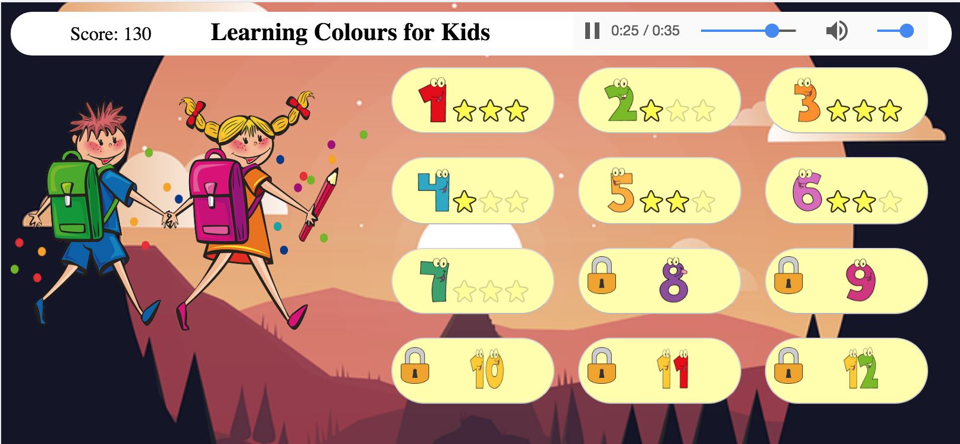

Figure 1 Responsive for Desktop PC

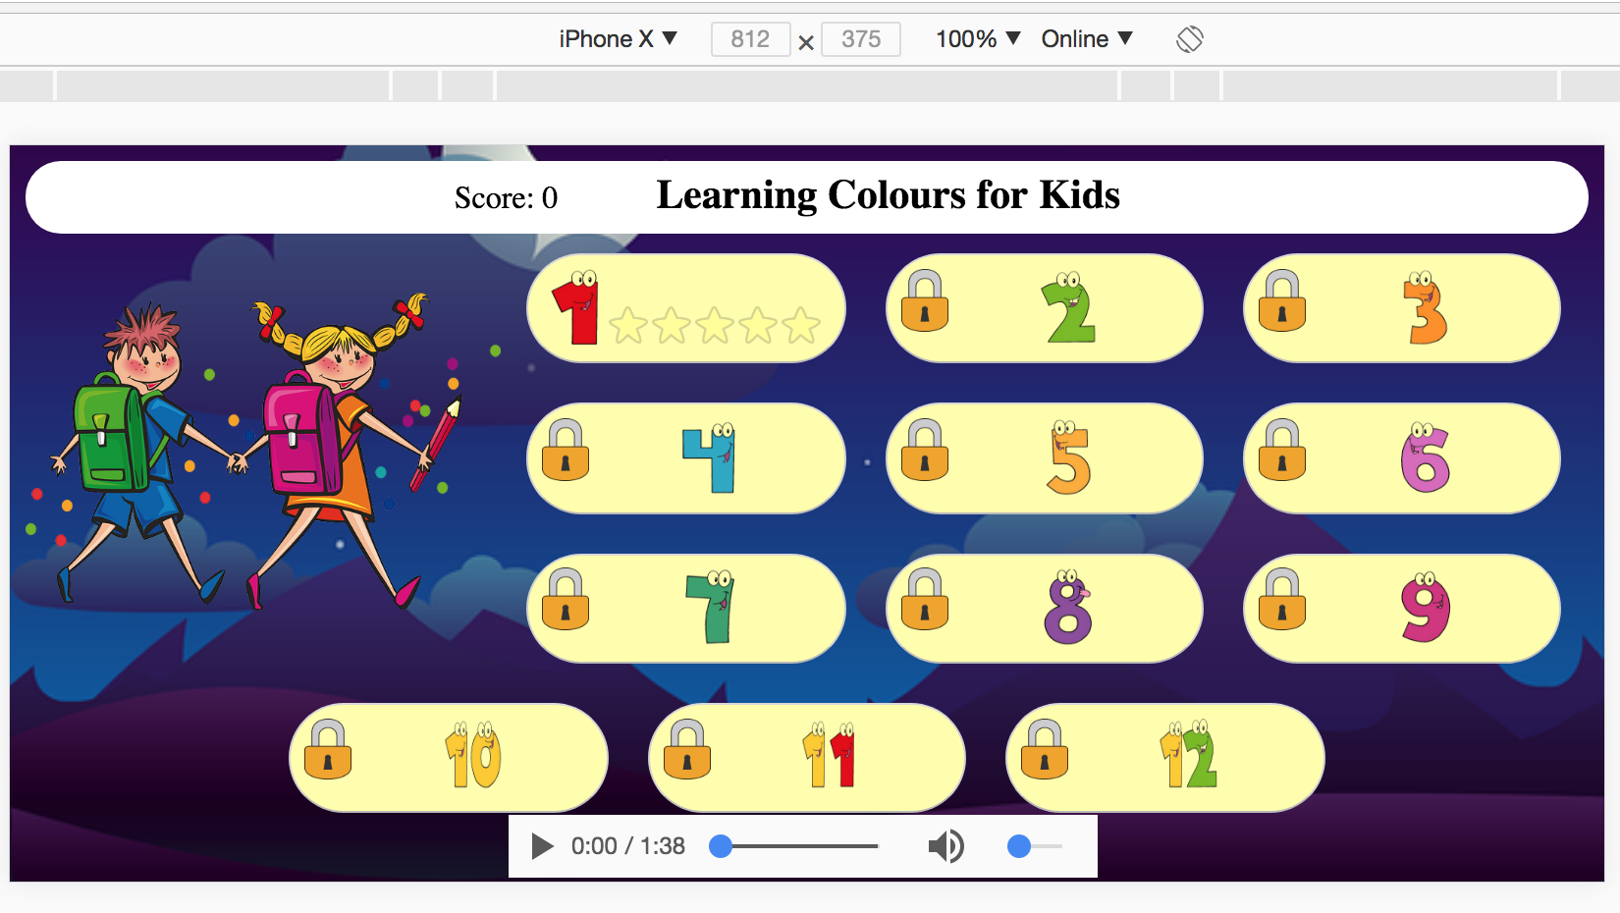

Figure 2 UI for iPhoneX in landscape mode

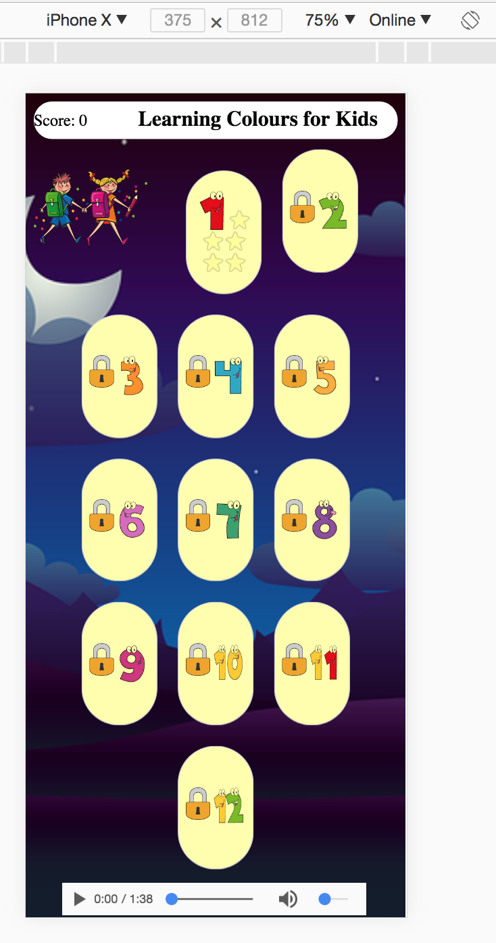

Figure 3 Game UI for iPhoneX in portrait mode

### Criteria: Code Structure [HD]

Reusable UI components are more than 4:

* createGameBodyUi(): Uses when game won, game over or user click play again
* createGameHeadUi(): Uses when game won, game over or user click play again
* loadBackground(): Called when new game loaded, go to home
* lockedLevel(level): Reused in loops, it does manual to create this component for all 12 buttons of 12 levels
* unlockedHomeLevels(): the same to lockedLevel
* createHomeButton(levelNumber, menuContainer): This is not to hard coded for 12 buttons at home screen, each component contain an image for level, a locked image or stars (one image to use for clear and unclear by opacity)

### Criteria: Data Structures [Distinction]

Complex data structure:

var currentGameSetting = {

currentLevel: 0,

baskets:[],

basketIndexes: []

};

currentGameSetting.baskets.push({

colour : colourList[newIndexRand],

balls: numberOfBall,

});

### Criteria: Bugs [Pass]

* No bugs, have been using chrome developer tools to inspect resources, errors, warning, …
* No user input invalid
* Restart and resume as appropriate

### Criteria: Readme [Credit]

* Include my name, app title, and an overview
* Explanations of major features

### Criteria: Demonstration Video [Credit]

* Demonstrate all main features
* Video is clear, audio is clear and easy to understand
* Similar to YouTube